Note on Serialization in Modern Industry
Serialization, Deserialization, and Externalization are core Java concepts used to convert objects into a byte stream and restore them later.
Object → Byte Stream → File / Network
Byte Stream → Object
These mechanisms are implemented using:
- Serializable
- Externalizable
- ObjectOutputStream
- ObjectInputStream
Important Note for Real-Time Projects
These mechanisms are mostly used in legacy Java systems today.
Modern applications rarely use Java’s built-in serialization because:
- It is Java-specific
- It has security risks
- It is not suitable for microservices and distributed systems
What Modern Industry Uses Instead
In modern backend development, JSON serialization is widely used.
Java objects are converted into JSON format using libraries such as:
- Jackson
Frameworks like:
- Spring Boot
automatically convert:
Java Object ⇄ JSON
This is used in:
- REST APIs
- Microservices
- Web services
- Data exchange between systems
Final Understanding
Serialization / Deserialization / Externalization
→ Learn for core Java knowledge and legacy systems
JSON Serialization
→ Used in modern real-time industry projects

Java Serialization & Deserialization

- What is Serialization
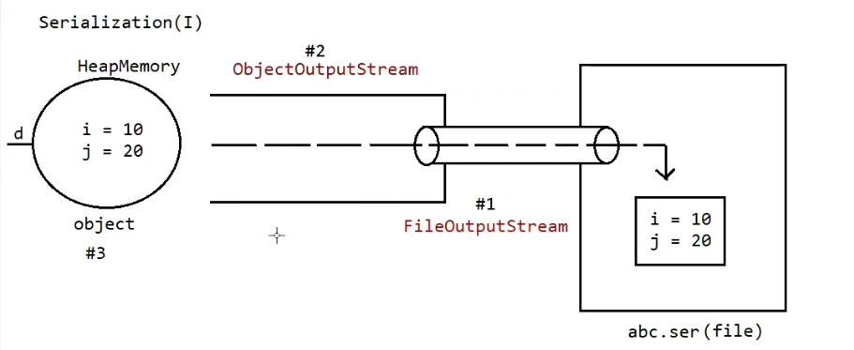
Serialization is the process of converting a Java object (in memory) into a binary format so that it can be:
- stored in a file
- sent through a network
- stored in cache
- persisted temporarily
In simple words:
Serialization converts a Java object → byte stream
Technical definition
Serialization is the process of converting an object from Java-supported form (heap memory) into file-supported form or network-supported form (byte stream).

Step 1 — Student Object in Heap
Student object
sid = 10
sname = sachin
saddr = MI
This object exists in JVM Heap memory.

Step 2 — ObjectOutputStream Serializes the Object
When we call:
oos.writeObject(student);
ObjectOutputStream:
✔ Reads object fields
✔ Converts them into serialized binary bytes
Example representation:
010101010101
101010101010
So now we have:
Serialized Binary Byte Stream

Step 3 — FileOutputStream Writes Bytes to File
FileOutputStream simply writes those bytes to the file.
It does not convert anything further.
Binary Bytes
↓
FileOutputStream
↓
abc.ser file

Final Flow (Correct)
Student Object (Heap)
↓
ObjectOutputStream
(converts object → binary bytes)
↓
Binary Byte Stream
↓
FileOutputStream
(writes bytes to file)
↓
abc.ser

- What is Deserialization
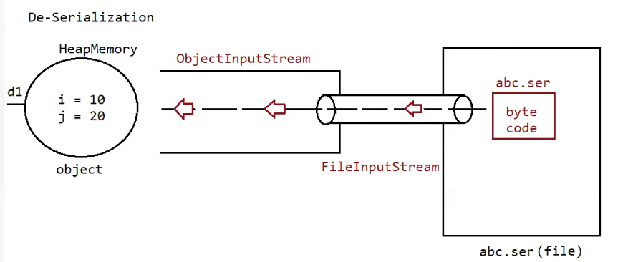
Deserialization is the process of converting a binary byte stream back into a Java object.
This binary data may come from:
- a file
- a network
- cache
- database storage
In simple words:
Deserialization converts byte stream → Java object
Technical definition:
Deserialization is the process of converting file-supported or network-supported binary data (byte stream) into a Java-supported object form in JVM heap memory.

Step 1 — Serialized File on Disk
After serialization, the object is stored in a file.
Example file:
abc.ser
This file contains:
Serialized Binary Data
(Byte Stream)
Example representation:
010101010101
101010101010
This data represents the state of the object.

Step 2 — FileInputStream Reads Binary Bytes
First we open the file using FileInputStream.
Example code:
FileInputStream fis = new FileInputStream("abc.ser");
FileInputStream:
✔ reads binary bytes from the file
✔ provides those bytes as an input stream
Flow:
abc.ser file
↓
FileInputStream
↓
Binary Byte Stream
FileInputStream does not convert anything.
It only reads the bytes from the file.

Step 3 — ObjectInputStream Reconstructs the Object
Next we wrap FileInputStream inside ObjectInputStream.
Example code:
ObjectInputStream ois = new ObjectInputStream(fis);
Student s = (Student) ois.readObject();
ObjectInputStream:
✔ reads the binary byte stream
✔ converts those bytes back into a Java object
So internally it reconstructs:
Student object
sid = 10
sname = sachin
saddr = MI
This object is recreated in JVM Heap memory.

Final Flow (Correct)
abc.ser (File on Disk)
↓
FileInputStream
(reads bytes from file)
↓
Binary Byte Stream
↓
ObjectInputStream
(converts bytes → object)
↓
Student Object (Heap)
sid = 10
sname = sachin
saddr = MI

Complete Picture (Serialization + Deserialization)
Serialization
Student Object (Heap)
↓
ObjectOutputStream
↓
Binary Byte Stream
↓
FileOutputStream
↓
abc.ser (File)
Deserialization
abc.ser (File)
↓
FileInputStream
↓
Binary Byte Stream
↓
ObjectInputStream
↓
Student Object (Heap)

One Simple Way to Remember
Serialization:
Object → Bytes → File
Deserialization:
File → Bytes → Object

3. Binary Data Streams
Binary data streams use:
InputStream
OutputStream

4. State of an Object
The state of an object means:
The data stored in its instance variables along with their current values at runtime.
In other words:
Object State = Instance Variables + Their Values

Example
class Student {
int sid = 10;
String name = "Sachin";
String address = "MI";
}
When we create an object:
Student s = new Student();
The object in heap memory contains:
sid = 10
name = "Sachin"
address = "MI"

Conceptual Definition (Object State)
When we say:
Object State = Instance Variables + Their Values
we mean logically the state of the object.
Example:
sid = 10
name = Sachin
address = MI
This pair (variable → value) represents the state of the object.
So conceptually:
state = sid=10, name=Sachin, address=MI

What Serialization Actually Writes
When serialization happens, Java does not store the variable names as text like this:
sid = 10
name = Sachin
Instead it stores the values in a structured binary format, following the class structure.
Example conceptual file:
10
Sachin
MI
Why?
Because the receiver already has the class definition:
class Student {
int sid;
String name;
String address;
}
So Java already knows:
first value → sid
second value → name
third value → address
Thus the mapping is reconstructed.

Simple Analogy
Think of it like a form template.
Template (class):
Student
-------
sid
name
address
Serialized data (file):
10
Sachin
MI
When reading:
sid ← 10
name ← Sachin
address ← MI
So the variable names come from the class, while values come from the file.

These values are converted into binary byte stream and stored in the .ser file.
Example conceptual representation:
101010101010
010101010101

Important Note
Serialization stores:
✔ instance variable values
✔ object data (state)
Serialization does NOT store:
❌ methods
❌ constructors
❌ static variables
❌ transient variables

5. Serializable Interface
For an object to be serialized:
Its class must implement Serializable.
import java.io.Serializable;
class Student implements Serializable {
}
Important facts
- Serializable is in java.io package
- It does not contain any methods
- It is a marker interface
Marker Interface
A marker interface does not contain methods.
It only marks the class, telling JVM to provide special behavior.
Examples:
Serializable
Cloneable
RandomAccess
JVM checks this marker during serialization.

6. Important Rules of Serialization
Rule 1
Only serializable objects can be serialized.
Rule 2
If a class does not implement Serializable and we try to serialize it:
Runtime exception occurs.
java.io.NotSerializableException
Rule 3
We can write multiple objects into a file.
Example
oos.writeObject(obj1);
oos.writeObject(obj2);
oos.writeObject(obj3);
Rule 4
Objects must be read in the same order they were written.
Example
Dog
Cat
Rat
Reading must also be:
Dog
Cat
Rat
Otherwise ClassCastException may occur.

7. Reading Unknown Object Order
If we don't know the order of objects stored in file:
Use instanceof.
Example
Object obj = ois.readObject();
if(obj instanceof Dog){
Dog d = (Dog)obj;
}
if(obj instanceof Cat){
Cat c = (Cat)obj;
}

